BIOS 6624: Advanced Statistics and Analysis
Project 0
Rachel Austin
Introduction
Data were provided for 31 subjects who collected saliva samples four times daily over three successive days using the novel SPIT booklet-based collection method paired with an electronic monitoring cap. Samples were collected upon waking, 30 minutes after waking, before lunch and 600 minutes after waking. The investigator was interested in whether at home saliva sampling yielded measurements comparable to laboratory collection and whether at home hormone patterns aligned with expected trends. Three primary questions guided this analysis: agreement between electronic cap and booklet sample times, adherence to sampling windows, and characterization of diurnal cortisol and DHEA trajectories. Agreement was evaluated using a mixed-effects model, with an intercept of zero and slope of one indicating perfect agreement. Adherence was summarized descriptively by method (booklet, electronic cap) and sampling time. Hormone trajectories were examined using mixed-effects models to quantify changes over time since waking, with particular interest in assessing whether cortisol followed typical laboratory patterns.
Methods
Data Management
Data management and cleaning procedures were performed prior to the analysis. There were 35 missing booklet sample collection times, 61 missing electronic cap collection times, five missing cortisol values and five missing DHEA values. Subject 3029 incorrectly had all samples recorded as occurring on day number 3, and these values were updated to align with the correct day number. Missing electronic cap and booklet sampling times were not imputed and were excluded from analysis requiring those measures.
Cortisol values (nmol/L) were screened for outliers using histograms and spaghetti plots. Based on investigator guidance that cortisol levels above 80 nmol/L were likely laboratory errors, and these values were excluded. DHEA values were capped at the laboratory upper limit of 5.205 nmol/L. Subject 3037 was removed because their DHEA values repeatedly reached this upper limit, suggesting potential unrelated biological issues. Although cortisol values above 26 nmol/L were noted as abnormal but possible, Subject 3024’s elevated values were reviewed and retained because their overall trend was consistent with expected laboratory patterns.
Several new variables were created for data management purposes. Booklet minutes, electronic cap minutes and wake minutes were calculated from booklet clock time, electronic cap clock time and sleep diary reported wake time, respectively. Cap interval minutes captured the time between electronic cap sample time and wake time, and booklet interval minutes captured time between booklet recorded sample time and wake time. These variables were used for adherence and agreement calculations.
Figure 1 presents descriptive statistics for the complete dataset, with no observations excluded, as analyses relied on different variables and retaining all available data minimized unnecessary loss of information in this small sample. For question one, which depended on booklet and electronic cap time adherence, only non-missing pairs were included, and observations with missing booklet or cap times were excluded. For question two, adherence proportions were calculated by tracking the number of non-missing cap and booklet times. For question three, missing cortisol and DHEA values were excluded, along with the cortisol level of above 80 nmol/L.
Analysis
Question 1
To visually assess agreement between electronic cap and booklet recorded sample times, a scatter plot was constructed with an identity line representing perfect agreement (Figure 2). Additionally, a linear mixed-effects model was fit with booklet time minus sleep diary clock time as the outcome and electronic cap time minus sleep diary clock time as the primary explanatory variable. A random intercept for subject ID was included to account for correlation among repeated samples within individuals. This approach allowed evaluation of the association between booklet and cap timing while accounting for within-subject clustering.
Question 2
Booklet and electronic cap adherence levels were evaluated using investigator-defined timing windows. Good adherence was defined as a booklet or electronic cap sample time occurring within ±7.5 minutes of the expected sampling time. For sample 2, this corresponded to 22.5-37.5 minutes after waking, and for sample 4 to 592.5-607.5 minutes. Adequate adherence was defined more broadly, with sample 2 occurring between 15 and 45 minutes after waking and sample 4 between 585 minutes and 615 minutes. The number of missing observations by sample and by measurement method (electronic cap versus booklet) was tracked, along with the number of samples meeting good and adequate adherence criteria (Figure 3). All observations meeting good adherence criteria were also classified as adequately adherent, consistent with investigator guidance.
Question 3
Preliminary data exploration included histograms of cortisol and DHEA to assess distributional properties, as well as spaghetti plots to visualize within-subject patterns over time (Figure 5 & 6). Both hormones exhibited right-skewed distributions, motivating log transformation prior to modeling. Cortisol was expected to exhibit a post-waking spike around 30 minutes. Timing of peak cortisol was examined to confirm a consistent increase around 30 minutes after waking, which supported use of a piecewise linear model with a knot at 30 minutes. Timing of peak DHEA was then summarized by day and subject to assess whether a similar post waking pattern was present. Most DHEA peaks occurred at waking so stepwise modeling was deemed unnecessary for DHEA.
Linear mixed-effects models were used to quantify changes in cortisol and DHEA over time while accounting for repeated measures within subjects. For DHEA, log-transformed values were modeled as a function of booklet time with a random intercept for subject ID. Booklet time was selected over cap time due to better protocol adherence. For cortisol, a piecewise linear mixed-effects model was fit with log-transformed cortisol as the outcome, booklet time as the primary explanatory variable, and a knot at 30 minutes post-waking to capture expected nonlinear patterns. Random intercepts for subject ID were included in both models.

Results
Question 1
A linear mixed-effects model demonstrated strong agreement between electronic cap and booklet recorded sample times. For every one-minute increase in recorded cap time, recorded booklet time increased by 0.995 minutes (95% CI: 0.981, 1.008, p-value: <0.0001). This suggested there is strong agreement between recorded cap time and recorded booklet time. However, the intercept indicated systematic bias, with subjects recording sample collection in their booklet an average of 6.508 minutes (95% CI: -12.259, -0.799, p-value: 0.029) earlier than the electronic cap time.
Question 2
A total of 93 samples were expected at both the 30 minute and 600 minute time points. At sample 2, there were 23 missing electronic cap times and 6 missing booklet times. At sample 4, there were 10 missing electronic cap times and 13 missing booklet times. Adherence for both electronic cap and booklet samples is displayed in Figure 3. Across both time points and adherence thresholds, booklet recorded samples demonstrated higher adherence than electronic cap samples. This indicates more consistent compliance with protocol when using booklet recording.
Question 3
Diurnal changes in cortisol were examined using a piecewise linear-mixed effects model with a knot at 30 minutes post-waking and a random intercept for subject. Cortisol increased by approximately 0.6% per minute (95% CI: -0.1%, 1.3%, p-value: 0.093) from waking to 30 minutes. After 30 minutes, cortisol declined by approximately 0.2% per minute (95%CI: -0.3%, -0.2%, p-value: < 0.001). Changes in DHEA across time were analyzed using a linear mixed-effects model with a random intercept for subject. DHEA declined by approximately 0.2% per minute across the day (95% CI: -0.22%, -0.18%, p-value: < 0.001).
Discussion
Agreement between electronic cap and booklet sampling times was high, although booklet times were generally recorded earlier than cap times. This suggests a small systematic bias potentially related to self-reporting delays. Booklet adherence exceeded electronic cap adherence at both sampling points, which may reflect that sleep diary wake time and booklet sampling time were self-reported. Cortisol showed a modest increase in the first 30 minutes after waking followed by a strong decline across the day. DHEA did not have as pronounced of a peak as cortisol and instead decreased gradually throughout the day. Limitations include reliance on self-reported wake and booklet sample times and missing data. Despite these limitations, findings suggest strong agreement between sampling methods with small systematic differences and support the feasibility of at-home saliva collection for recording hormone data.
Reproducible Research Information
The code used to generate this report is found in this public GitHub repository: https://github.com/austinrach/BIOS6624. The data file used for the analysis is hidden from the public repository but stored on my local computer and on the course canvas page. RStudio Version 2023.09.1+494 was used for this analysis.

Figures
Figure 1
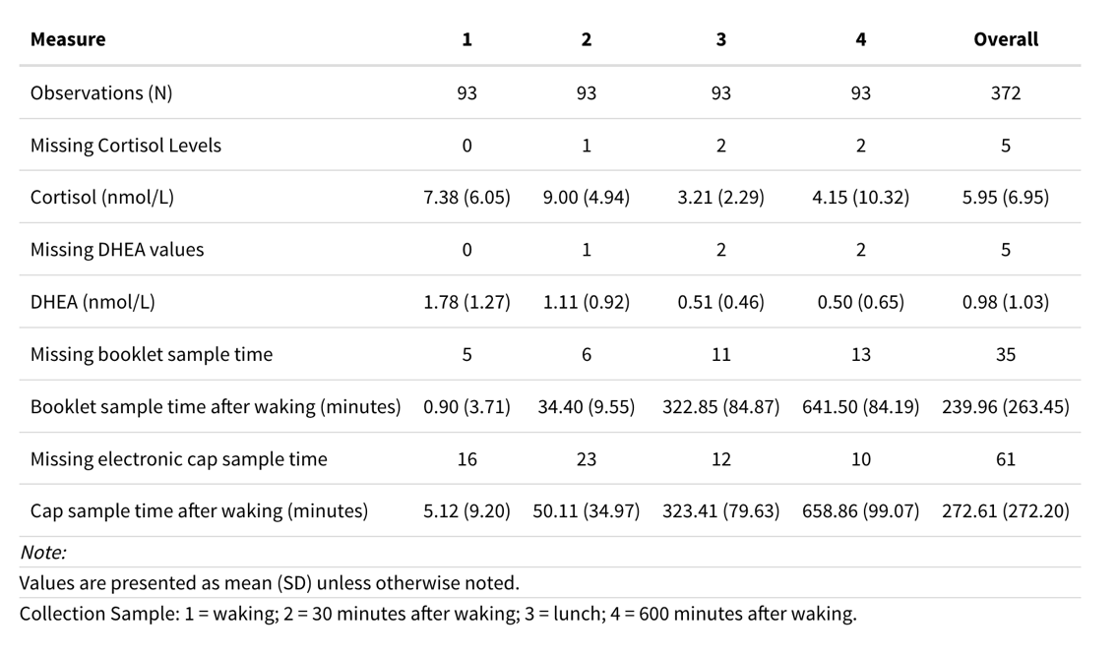
Figure 2
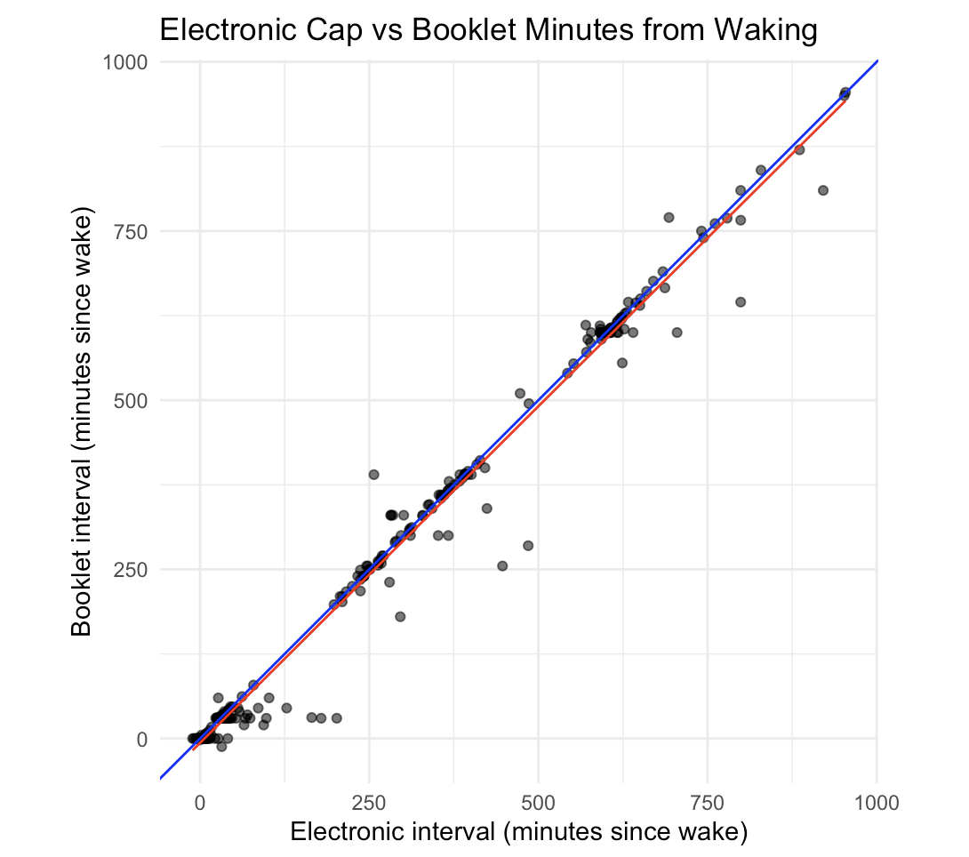
Figure 3
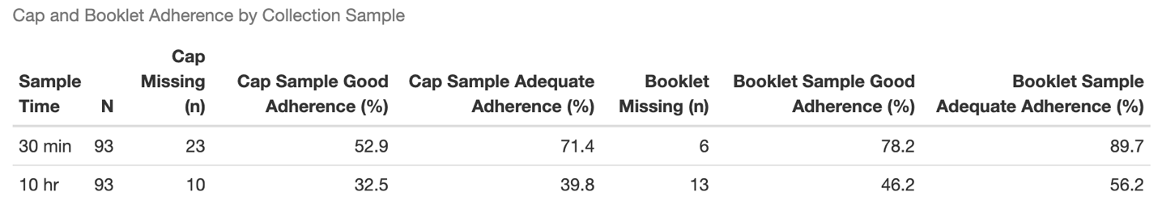
Figure 4
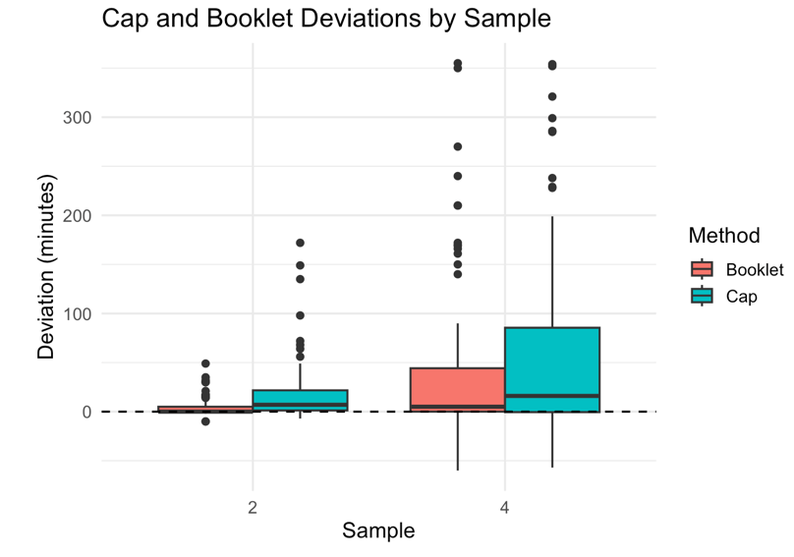
Figure 5
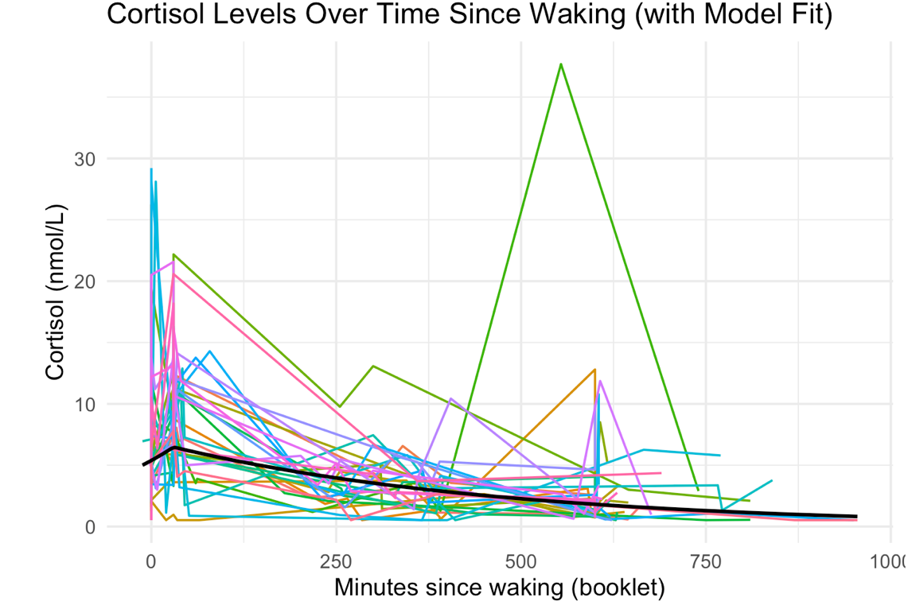
Figure 6
